**SAVEETHA SCHOOL OF ENGINEERING**

**CAPSTONE PROJECT**

**NAME:** k.showkath ali

**REGISTER NUMBER:** 192324224

**COURSE CODE:** CSA0747

**COURSE NAME:** Computer Network for IOT

|  |  |
| --- | --- |
| **INTRODUCTION:** | |
| Network traffic analysis and optimization is essential for improving the performance and security of modern networks. By data flows and identifying patterns, organizations can detect anomalies, prioritize critical applications, and manage bandwidth effectively. Techniques such as traffic shaping and deep packet inspection help reduce latency and prevent congestion, ensuring a smoother user experience. Additionally, continuous monitoring allows for proactive adjustments to adapt to changing conditions, ultimately transforming network performance into a strategic advantage for businesses.    **Objective:**   * **Enhance Network Performance**: Identify and eliminate bottlenecks. * **Strengthen Security Posture**: Detect and respond to threats. * **Facilitate Troubleshooting**: Quickly resolve network issues. * **Enable Capacity Planning**: Inform infrastructure investments. * **Ensure Compliance**: Maintain logs for regulatory requirements.   **LITERATURE REVIEW**  **A literature review on network traffic analysis and optimization highlights various techniques designed to enhance network performance and security. Key methods include packet capture and deep packet inspection, which help identify threats and optimize resource usage. Advances in traffic prediction models, such as neural networks, enable effective forecasting of network behavior, improving resource allocation. Optimization strategies like traffic shaping ensure critical applications receive necessary bandwidth while minimizing latency. The emergence of Software-Defined Networking (SDN) has further transformed network management by centralizing control, although challenges with scalability and legacy systems remain. Overall, continuous research in this area is essential for addressing new challenges and leveraging innovative technologies**  **.METHODOLOGY**  **Software:**   * Cisco Packet Tracer   **Network Design:**  Network consist of   * + 4 Switches   + 5 PC   **IP Address Allocation:**   1. **STEP 1**: Start Packet Tracer 2. **STEP 2:** Choosing Devices and Connections 3. **STEP 3**: Building the Topology 4. **STEP 4:** Connecting the Host to Switches 5. **STEP 5**: Select a switches and once a 2950-24 switches 6. **STEP 6**: Connect PCs to switch by first choosing connections 7. **STEP 7**: Click on PC2 and Choose Fast Ethernet 8. **STEP 8**: Drag the cursor to Switch0 9. **STEP 9**: Configure IP Address and Subnet Masks on the Host 10. **STEP 10**: To confirm Data transfer between the devices.   **Protocol:** | |
|  | * Test internal communication between devices. * Verify internet access from various devices within the LAN. * Check network speed and performance to ensure efficiency. * Monitor network load and identify any bottlenecks. |

* Perform vulnerability scans to identify potential security issues.
* Ensure that firewall rules are correctly implemented and functioning.

**RESULT:**

**Network Design:**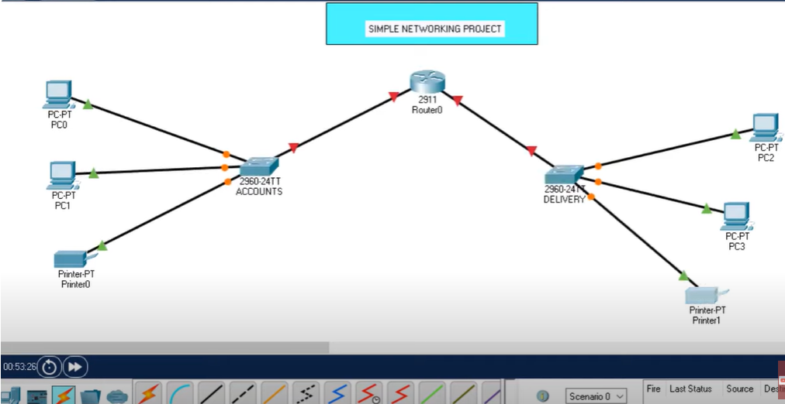

# CONCLUSION: In conclusion, comprehensive network traffic analysis and optimization are vital for ensuring the performance, security, and reliability of modern networks. By employing a variety of techniques such as packet capture, traffic prediction models, and optimization strategies, organizations can effectively manage network resources, detect anomalies, and enhance user experiences. The integration of advanced technologies like Software-Defined Networking (SDN) offers new opportunities for improved network management but also presents challenges that require ongoing research and adaptation. As networks continue to evolve with the increasing complexity of applications and security threats, the importance of robust traffic analysis and optimization strategies will only grow, positioning them as essential components of a proactive network management framework.